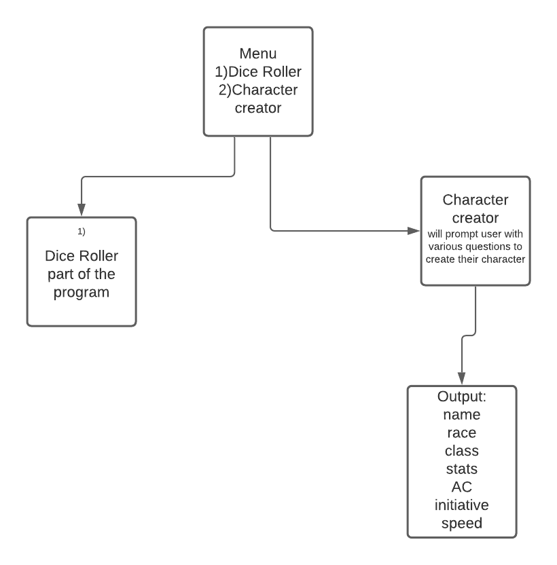

The Menu screen will be a basic tkinter gui screen with a menu label and 2 buttons that are in the 7th and 8th row to ensure they are at the bottom of the other pages

The dice roller program will have buttons stacked starting at the first row and working down 1 button for each die, it will then output at the top of the page row 0.

The character creator program: there will be a list of labels starting from row 1 and working down. In an adjacent column, the entry box for the corresponding labels will be lined up in the same rows

The submit button will be right below that. Below the submit button will be a message on how the stats work in this program. Below that are the dice roller and character creator buttons that were on the menu page

The output will be the same as the character creator program with the way the labels line up, except the entry boxes are replaced with finalized values in its place. The submit button is gone and the message is replaced with a concluding message.